Lampiran II
Hasil Olahan SPSS

DESCRIPTIVES VARIABLES=X1_TenagaKerja X2_JumlahPerusahaan X3_BiayaInput Y_PDRB/STATISTICS=MEAN STDDEV MIN MAX.

Descriptives

Descriptive Statistics
 | N | Minimum | Maximum | Mean | Std. Deviation
X1_TenagaKerja | 30 | 3198 | 6498 | 4952.07 | 931.235
X2_JumlahPerusahaan | 30 | 12 | 70 | 34.30 | 17.981
X3_BiayaInput | 30 | 106.97 | 8142.26 | 2058.1753 | 2255.06791
Y_PDRB | 30 | 149.86 | 12742.05 | 3224.4480 | 3405.80548
Valid N (listwise) | 30

REGRESSION
/DESCRIPTIVES MEAN STDDEV CORR SIG N
/MISSING LISTWISE
/STATISTICS COEFF OUTS
/CRITERIA=PIN(.05) POUT(.10)
/NOORIGIN
/DEPENDENT Y_PDRB
/METHOD=ENTER X1_TenagaKerja X2_JumlahPerusahaan X3_BiayaInput
/SCATTERPLOT=(*SDRESID ,*ZPRED) (*SDRESID ,Y_PDRB)
/RESIDUALS DURBIN HISTOGRAM(ZRESID) NORMPROB(ZRESID).

Regression

Coefficientsª
Model |  | Unstandardized Coefficients |  | Standardized Coefficients | t | Sig.
 |  | B | Std. Error | Beta | t | Sig.
1 | (Constant) | 916.318 | 697.390 |  | 1.314 | .200
1 | X1_TenagaKerja | -.048 | .139 | -.013 | -.345 | .733
1 | X2_JumlahPerusahaan | -11.945 | 7.967 | -.063 | -1.499 | .146
1 | X3_BiayaInput | 1.436 | .076 | .951 | 18.812 | .000
a. Dependent Variable: Y_PDRB

Coefficientsª
Model |  | Collinearity Statistics
 |  | Tolerance | VIF
1 | (Constant)
1 | X1_TenagaKerja | .539 | 1.854
1 | X2_JumlahPerusahaan | .439 | 2.277
1 | X3_BiayaInput | .304 | 3.286
a. Dependent Variable: Y_PDRB

Model Summary^{b}
Model | R | R Square | Adjusted R Square | Std. Error of the Estimate | Durbin-Watson
1 | .990ª | .980 | .977 | 511.27537 | 1.208
a. Predictors: (Constant), X3_BiayaInput, X1_TenagaKerja, X2_JumlahPerusahaan
b. Dependent Variable: Y_PDRB
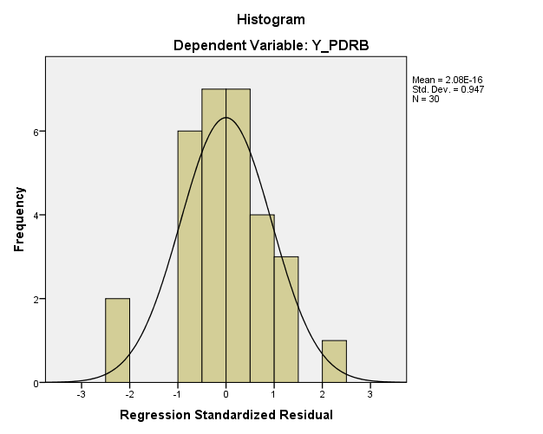
Model Summary^{b}
Model | R | R Square | Adjusted R Square | Std. Error of the Estimate | Durbin-Watson
1 | .990ª | .980 | .977 | 511.27537 | 1.208
a. Predictors: (Constant), X3_BiayaInput, X1_TenagaKerja, X2_JumlahPerusahaan
b. Dependent Variable: Y_PDRB

Coefficientsª
Model |  | Unstandardized Coefficients |  | Standardized Coefficients | t | Sig.
 |  | B | Std. Error | Beta | t | Sig.
1 | (Constant) | 916.318 | 697.390 |  | 1.314 | .200
1 | X1_TenagaKerja | -.048 | .139 | -.013 | -.345 | .733
1 | X2_JumlahPerusahaan | -11.945 | 7.967 | -.063 | -1.499 | .146
1 | X3_BiayaInput | 1.436 | .076 | .951 | 18.812 | .000
a. Dependent Variable: Y_PDRB

ANOVAª
Model |  | Sum of Squares | df | Mean Square | F | Sig.
1 | Regression | 329589353.868 | 3 | 109863117.956 | 420.283 | .000^{b}
1 | Residual | 6796465.103 | 26 | 261402.504
1 | Total | 336385818.971 | 29
a. Dependent Variable: Y_PDRB
b. Predictors: (Constant), X3_BiayaInput, X1_TenagaKerja, X2_JumlahPerusahaan

